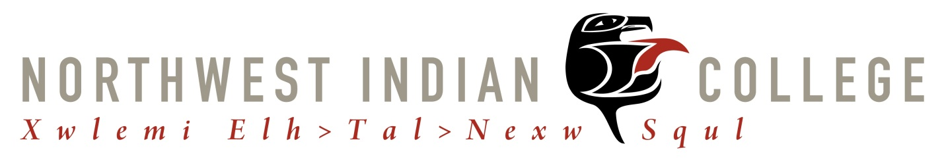
Policy for Accommodations for Students with Disabilities

Northwest Indian College complies with Section 504 of the Rehabilitation Act of 1973, 29 U.S.C. section 794, and the Americans with Disabilities Act, 42 U.S.C. section 12101, et seq., which require that reasonable academic accommodations be provided to qualified individuals with disabilities.

Northwest Indian College supports individuals with disabilities in undertaking and completing a college placement exam, GED/ABE program, and certificate program or college degree. NWIC recognizes that certain disabilities may make completion of a program more difficult, but that do not restrict a student’s ability to meet the standards of a respective certificate or degree. It is therefore committed to providing reasonable academic accommodations and assistance to support successful completion of an educational program in ways that provide students with disabilities an equal opportunity for educational development.

Operating responsibility for the implementation of this policy and procedure lies with the Dean of Students or his/her designee. Upon documentation and determination of necessary and reasonable accommodations, NWIC will begin coordination of services within two weeks prior to the quarter starting. The Dean of Academics and Distance Learning and Dean of Students can coordinate accommodations for enrolled students with documented disabilities.

Definitions

A person with a disability is any individual who:
- has a physical or mental impairment that substantially limits one or more major life activities;
- has a record of such impairment.

A qualified person with a disability is:
A person protected by law including those who would be able to meet the academic and technical standards required for participation in, and/or fulfillment of the essential requirements of college programs or activities.

Reasonable Academic Accommodations

Academic accommodations are those accommodations necessary to provide students with disabilities equal opportunity for professional development, and advance their acquisition of an educational certificate or degree. Accommodations will be considered unreasonable to the extent that they:
- fundamentally alter or substantially modify the nature or mission of education at NWIC;
- impose undue financial or administrative hardship on NWIC;
- lower academic or other essential performance standards
- pose health or safety hazard to the individual or others

Financial Responsibility

Northwest Indian College will not bear the expenses related to the verification of disability. Depending on the accommodation need, NWIC may have to refer a student out to a third party to help financially assist or pay for an accommodation. These resources may include Tribal Health and human Services programs, Tribal Vocational Rehabilitation, State Department of Vocational Rehabilitation, etc.

Confidentiality

When handling medical records of students, NWIC will handle them with the upmost care and concern and will follow appropriate HIPAA requirements when storing these documents.

