NWIC LUMMI CAMPUS HOUSING

Residence life center (RLC)
- Lummi campus offers affordable housing for you and your family. Our 67-person dorm is smoke/drug and alcohol free and within walking distance to your classes. Rates are based on student income and need.
- Residence life center cost $900 per quarter and meal plan is required which cost $750 per quarter.
- RLC houses 64 students and 3 residential students.
- Furnished lounge Includes full kitchen, tv/satellite, and dinning area

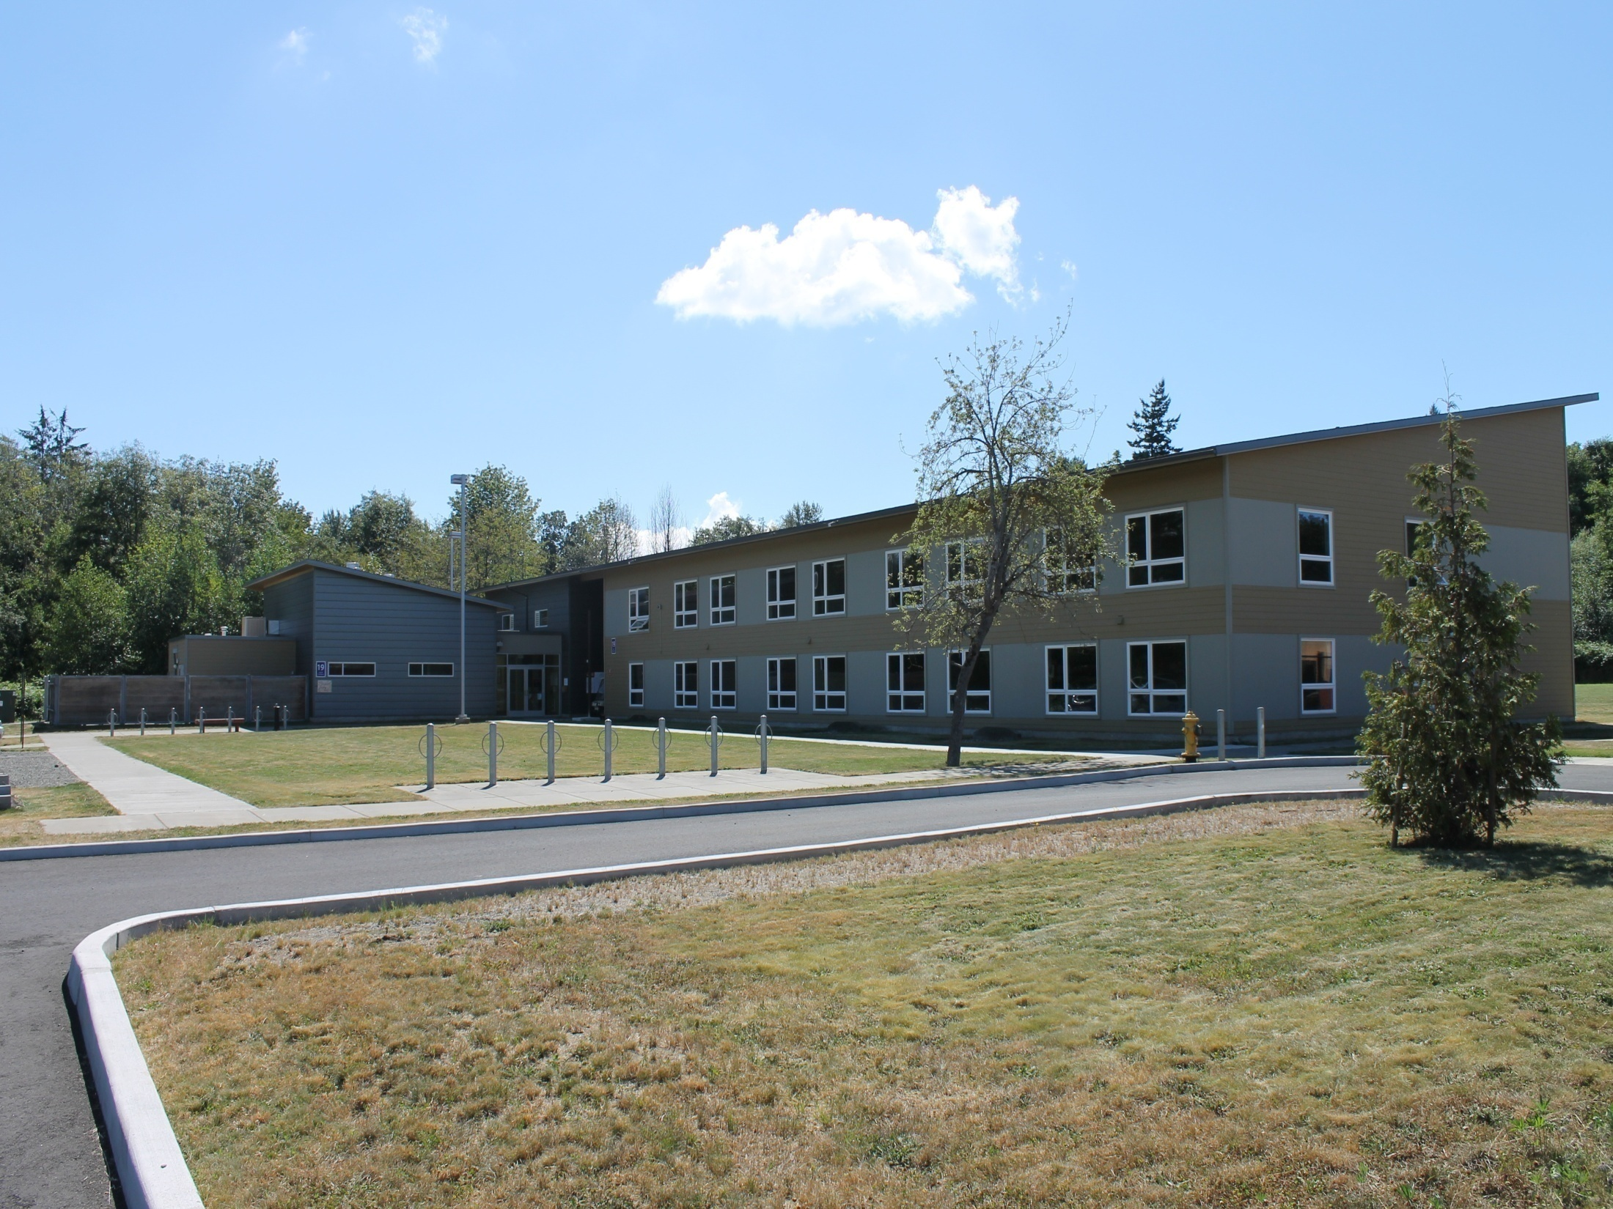

NWIC LUMMI CAMPUS HOUSING

KWINA VILLAGE APARTMENTS (KVA)
- KVA are 1-3 bedrooms they are family need first meaning students with families will get priority to have an apartment.
- Located 0.5 mile from Lummi Main Campus.
- Students at KVA may buy meal plan from RLC but it is not required.
- Housing application include a $50 fee.

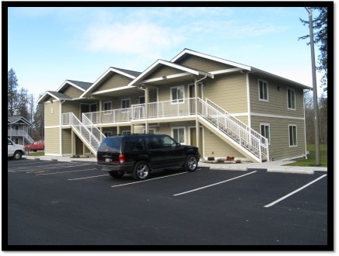

- NWIC student dorms and apartments are limited and reach maximum capacity each year so I encourage everyone to apply for housing ASAP.

